1996
February 5th 1996

11.- Ms. Marcela Ghiulbenghian President of “Sacred Treasure of Religions” Foundation and Ft. Univ. Prof. Dr. Alexandru I. Stan organized to the Palace Hall in Bucharest, a religious musical show of all ethnics and Romanian churches in honor of International Religions Day, glorifying God; the One known by all faiths.
The festivity was dedicated to the Love of God.
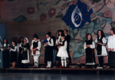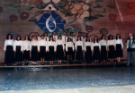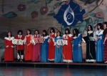

July 09th 1996
12.- The 1995A.P.A.R. balance sheets were carefully examined, and suggestions have been made for the next year. A.P.A.R. and the Foundation associated with WCRP (World Council of Religions and Peace). Members of APAR and Foundation were proposed to participate to the European section of WCRP conference.

September 09th 1996
13.- The invitations for the 10th -13th august 1996 Budapest Europe WCRP have been received. All the arrangements for the conference had been made to the embassy, visas, A.P.A.R. fliers, etc.

October 10th – 13th 1996
14.- A Foundation delegation participated to the “World Conference on Religion and Peace” Europe WCRP events. Meetings with representatives of various cults and religions have been organized where the Foundation’s ideas were shared and fliers distributed.
Ms. President Marcela Ghiulbenghian, Ft. Prof. Dr. Stan Alexandru, Stan Michael Wiliams, Dumitru Oana Lucia, Ilie Fonta(State Secretary of Cults), Imam Osaman Aziz and Father Albu Zoltan Zagoni attended the conference.

October 18th 1996
15.- From 9th – to 14th October 1996, the results of the meeting were discussed. The by-laws of the Foundation and A.P.A.R were changed. The meetings created opportunities and friendships between Romanian cults representatives. The idea of handing diplomas was borne.

October 23rd 1996
16.- The Children’s Palace hosted the diploma handing Festivity. The diplomas honored the glorifying of piece and understanding between ethnics and religions, the spiritual union of Romanian personalities.
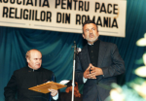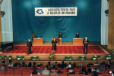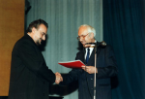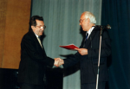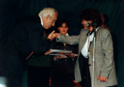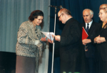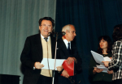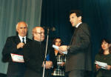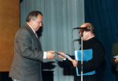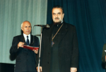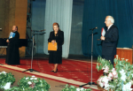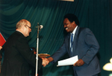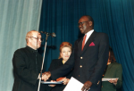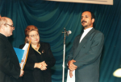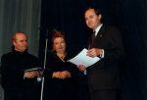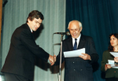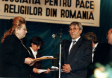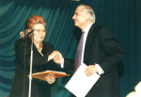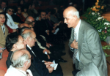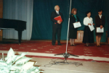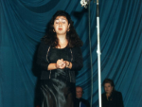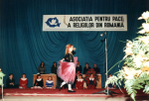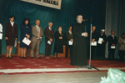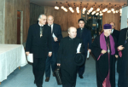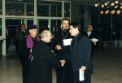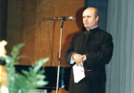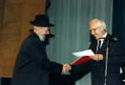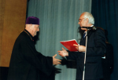

17.- In October 1996, the inauguration of FAPTE Club took place. President of FAPTE Association, Sacred Treasure Foundation and Peace of Romanian Religions Association, Ms. Marcela Ghiulbenghian had the honor. Mrs. Minister Norica Niculai, Ft. Univ. Prof. Dr. Alexandru I. Stan and 200 other women NGO representatives attended the festivity Ft. Univ. Prof. Dr. Alexandru I. Stan blessed the Club for it’s purpose.

18.- In December 1996 the APAR and Foundation manager sent congratulations cards to all religion representatives, Ministry of Cult and Culture, etc.

